Big data analytics lab

EXP-1: Installation of Hadoop framework, it components and study of the Hadoop ecosystem.

1. Introduction to Hadoop
Apache Hadoop is an open-source framework used for distributed storage and processing of large datasets across clusters of computers. It allows organizations to store and process big data efficiently using parallel processing.
Hadoop uses the distributed computing model, where data is divided and processed simultaneously across many nodes.

2. Installation of Hadoop Framework

Step 1: Install Java
Hadoop is written in Java, so Java must be installed.
Check Java version:
java -version
Install Java (if not installed):
sudo apt update
sudo apt install openjdk-8-jdk
Set Java path:
export JAVA_HOME=/usr/lib/jvm/java-8-openjdk-amd64

Step 2: Download Hadoop
Download Hadoop from the Apache website.
wget https://downloads.apache.org/hadoop/common/hadoop-3.3.6/hadoop-3.3.6.tar.gz
Extract the file:
tar -xvf hadoop-3.3.6.tar.gz
mv hadoop-3.3.6 hadoop

Step 3: Configure Environment Variables
Open .bashrc
nano ~/.bashrc
Add:
export HADOOP_HOME=~/hadoop
export PATH=$PATH:$HADOOP_HOME/bin:$HADOOP_HOME/sbin
Apply changes:
source ~/.bashrc

Step 4: Configure Hadoop Files
Go to Hadoop configuration directory:
cd $HADOOP_HOME/etc/hadoop

core-site.xml
<configuration>
<property>
<name>fs.defaultFS</name>
<value>hdfs://localhost:9000</value>
</property>
</configuration>

hdfs-site.xml
<configuration>
<property>
<name>dfs.replication</name>
<value>1</value>
</property>
</configuration>

mapred-site.xml
Copy template:
cp mapred-site.xml.template mapred-site.xml
Edit file:
<configuration>
<property>
<name>mapreduce.framework.name</name>
<value>yarn</value>
</property>
</configuration>

yarn-site.xml
<configuration>
<property>
<name>yarn.nodemanager.aux-services</name>
<value>mapreduce_shuffle</value>
</property>
</configuration>

Step 5: Format NameNode
hdfs namenode -format

Step 6: Start Hadoop Services
Start HDFS:
start-dfs.sh
Start YARN:
start-yarn.sh

Step 7: Verify Installation
Check running processes:
jps
Expected output:
- NameNode
- DataNode
- SecondaryNameNode
- ResourceManager
- NodeManager

3. Components of Hadoop

1. HDFS (Hadoop Distributed File System)
- Distributed storage system
- Stores large data across multiple machines
- Provides fault tolerance and high reliability

Main Components
- NameNode – Manages file system metadata
- DataNode – Stores actual data blocks
- Secondary NameNode – Maintains checkpoints

2. MapReduce
- Programming model for parallel data processing
- Divides tasks into two stages:
Map Phase
- Processes input data
- Produces key-value pairs
Reduce Phase
- Aggregates results

3. YARN (Yet Another Resource Negotiator)
- Manages cluster resources
- Schedules jobs
- Allows multiple applications to run on the cluster
Main Components:
- Resource Manager
- Node Manager
- Application Master

4. Hadoop Common
- Shared libraries and utilities
- Supports other Hadoop modules

4. Hadoop Ecosystem

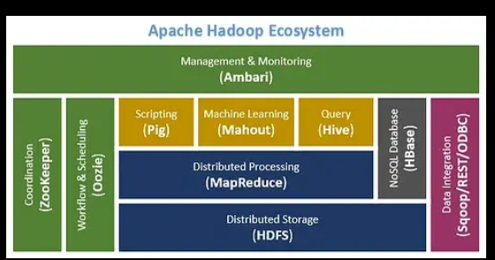

The Hadoop Ecosystem consists of tools and technologies that work with Hadoop to process, manage, and analyze big data.
Tool | Purpose
Hive | Data warehouse tool used for SQL queries on Hadoop
Pig | High-level scripting platform for data processing
HBase | NoSQL distributed database
Sqoop | Transfers data between Hadoop and relational databases
Flume | Collects and transfers large volumes of log data
Spark | Fast data processing engine for big data analytics
Oozie | Workflow scheduler for Hadoop jobs
Zookeeper | Coordination service for distributed applications

5. Advantages of Hadoop
- Handles very large datasets
- Scalable architecture
- Fault tolerant
- Cost effective
- Supports structured, semi-structured, and unstructured data

6. Conclusion
The Apache Hadoop framework provides a powerful platform for distributed storage and parallel processing of big data. Its core components (HDFS, MapReduce, YARN, and Hadoop Common) work together with ecosystem tools like Hive, Pig, HBase, and Spark to support advanced big data analytics.

